World No Tobacco Day: May 31, 2026
Social Media Resources to raise awareness on tobacco and bladder cancer
On #WorldNoTobaccoDay, we raise awareness about the dangers of tobacco use and its significant link to bladder cancer.
Smoking is the leading risk factor, responsible for around 50% of all bladder cancer cases.

By quitting or never starting, we can reduce the risk of developing bladder cancer and many other health issues.

We’ve prepared social media resources to help share this important message. Let’s join forces to create a future where fewer people are affected by tobacco-related cancers.

Together, we can promote healthier choices and prevent the harmful impact of smoking on our health.

Text | Visual
Today is #WorldNoTobaccoDay 🚭  Smoking is the leading risk factor for bladder cancer. It is responsible for around half of all cases.  Stopping smoking at any age can help lower the risk.  Together, we can raise awareness and support healthier futures.  @WorldBladderCan | Link to visual (high quality)  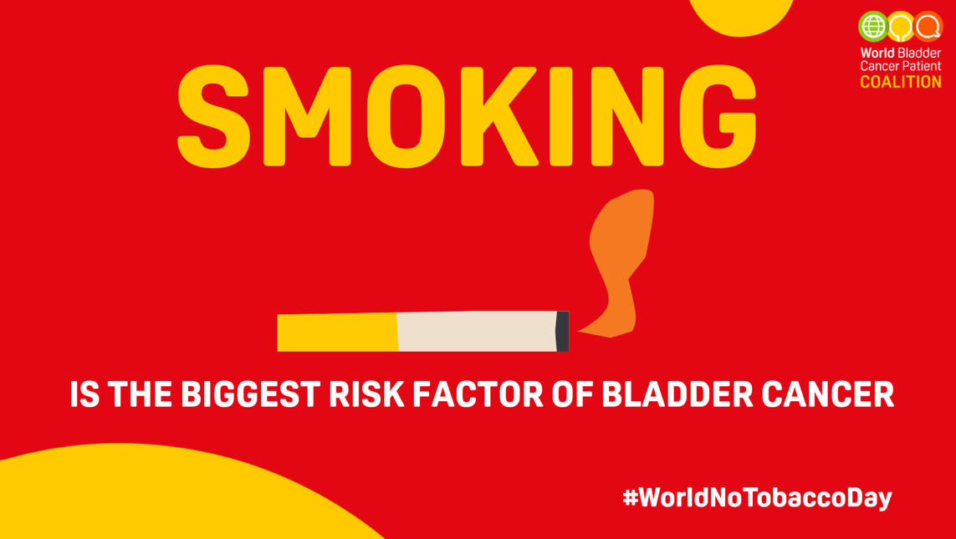
💡 Did you know❓  People who smoke are up to 4 times more likely to develop bladder cancer than non-smokers.  This #WorldNoTobaccoDay, let us work together to raise awareness about the link between tobacco use and bladder cancer. 🚭  @WorldBladderCan | Link to visual (high quality)  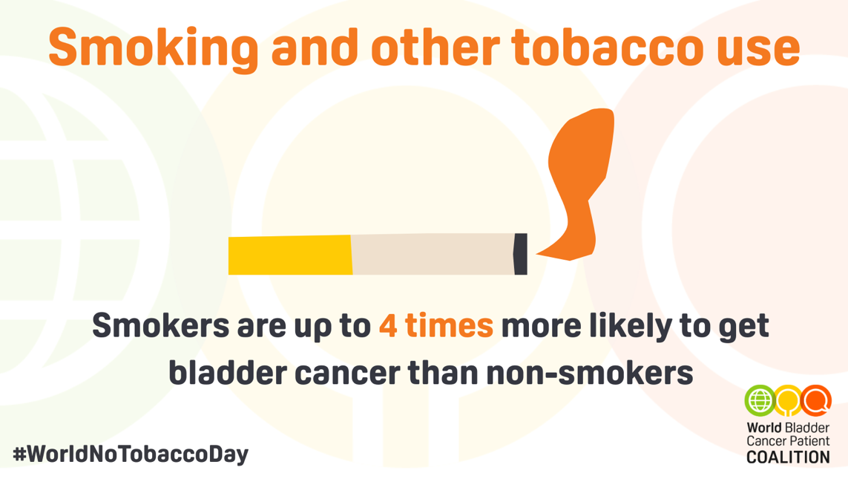
💡 Did you know❓  Smoking is responsible for around 50% of all bladder cancer cases. 🚭  This #WorldNoTobaccoDay, let us raise awareness about the risks and support healthier futures.  @WorldBladderCan | Link to visual (high quality)  